Federation University, in partnership with the Ballarat Wildlife Hospital, is leading a major research project to better understand the health, movement and disease risks of koalas, echidnas and birds of prey across the region.
By combining wildlife hospital records with post release tracking and disease surveillance, the study is building a clearer picture of how native animals recover from injury and survive after returning to the wild. Researchers are analysing animals admitted between 2022 and 2027, focusing on why they were rescued, their health on arrival, and how treatment and rehabilitation influence survival outcomes.
Animals considered fit for release are fitted with tracking devices and monitored in the wild. Their movements are analysed to understand how they use the landscape and which habitats are most important for recovery and survival.
One such story is “Mardi,” a young female koala hit by a vehicle in the middle of the night on the Midland Highway in Meredith in November 2025. She was rescued and transported to the Ballarat Wildlife Hospital for urgent care by locals Vicki and Sally. Her injuries were treatable, and after rehabilitation at Shanhaven Shelter she was released with a GPS enabled VHF tracking collar.
Unlike satellite collars, Mardi’s device stores data that must be downloaded manually. Researchers therefore spend long hours in the field using radio telemetry to locate her signal. While time consuming, this provides valuable insight, allowing direct observation of her condition, identification of the trees she uses, and a clearer understanding of habitat quality beyond mapped data.
It also enables collection of faecal samples for a collaborative antimicrobial resistance study with Macquarie University. This work is investigating whether antimicrobial resistance already exists in our local wildlife and/ or whether it is acquired during hospital or shelter care or after release.
Since release, Mardi has moved through farmland, roadside vegetation and tree lined gullies but has not yet crossed the highway where she was injured. Her movements highlight the importance of remnant vegetation and mature eucalypts such as manna gum (Eucalyptus viminalis), narrow leaf peppermint (Eucalyptus radiata) and messmate (Eucalyptus obliqua) in fragmented agricultural landscapes.
Tracking wildlife often depends on cooperation from local landholders. When signals lead onto private property, researchers must seek permission to enter, which can delay access and reduce opportunities to observe animals or collect samples. However, these partnerships can also produce valuable findings.
Recently, with landholder assistance, researchers tracked Mardi to a gully on private land and found her resting in an old peppermint tree. In an unexpected discovery, she was sharing the tree with another koala, something not previously recorded in several years of tracking. This provides encouraging evidence she has reintegrated into the local population and supports longer term recovery prospects for koalas in the Meredith area.
The project is supported by multiple organisations. Federation University has funded echidna tracking, WIRES has supported birds of prey monitoring, and the Victorian Government through the Wildlife Protection and Support Package 2022 to 2023 funded koala tracking equipment (this was a Ministerial grant executed by Andy Meddick AJP and managed by Ballarat Wildlife Rehabilitation and Conservation). Additional support, including laboratory analysis and disease research, is provided by the University of Melbourne and Macquarie University.
Researchers say the work would not be possible without wildlife rescuers and transporters who respond to calls at all hours, as well as a dedicated wildlife hospital and rehabilitation facility locally. Their work is often difficult and confronting, with no guarantee of success. Treating a single koala requires significant time, expertise and funding, making each release a shared achievement across multiple teams.
Local landholders also play a key role by protecting and restoring habitat and allowing access for tracking. Even small patches of native vegetation can provide essential refuge in fragmented landscapes.
Koalas are active year round, particularly from dusk to dawn and in the early morning. Drivers are urged to slow down in areas with wildlife signage and remain alert, as animals can appear suddenly on roads.
Through this research, the Ballarat Wildlife Hospital and Federation University hope to improve outcomes for injured wildlife and provide practical insights to guide conservation efforts, ensuring more animals like Mardi have a second chance in the wild.
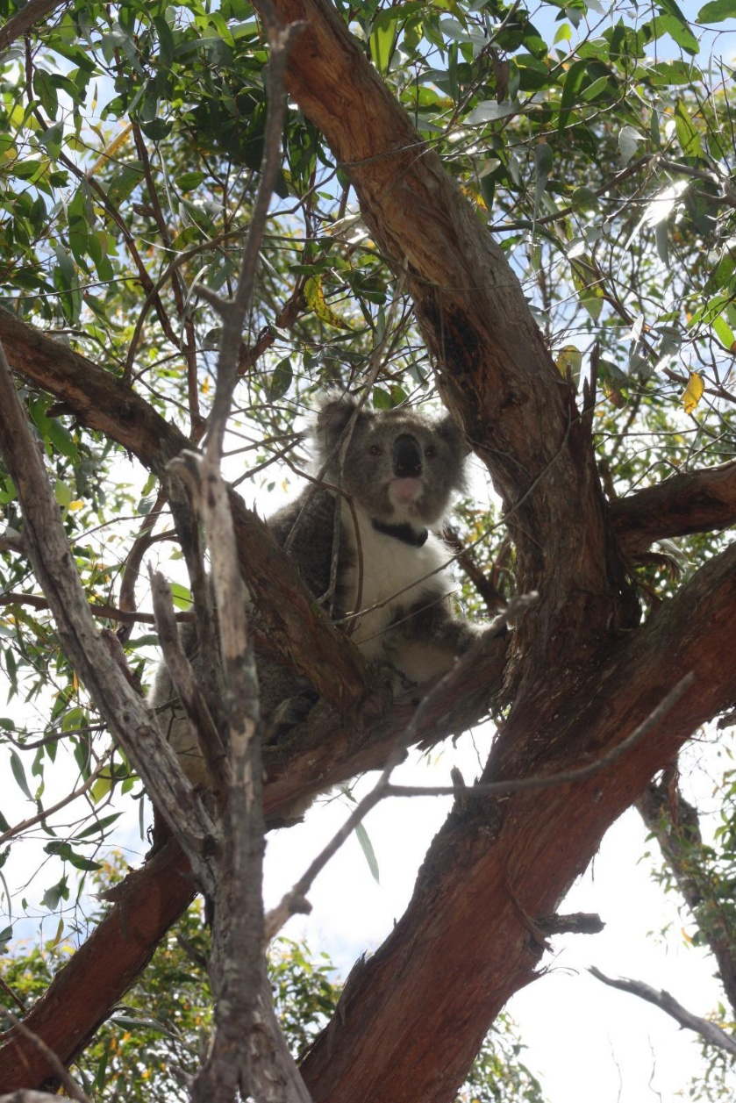
Mardi successfully released wearing her GPS enabled VHF radio-tracking collar. Image credit: Jessica Davies for Ballarat Wildlife Hospital.

Mardi being released into bushland near Meredith (left to right): Nikki Shanahan (Hospital Director), Sally Wall (wildlife responder), Naomi Gruneklee (Federation University student). Image credit: Jessica Davies for Ballarat Wildlife Hospital.
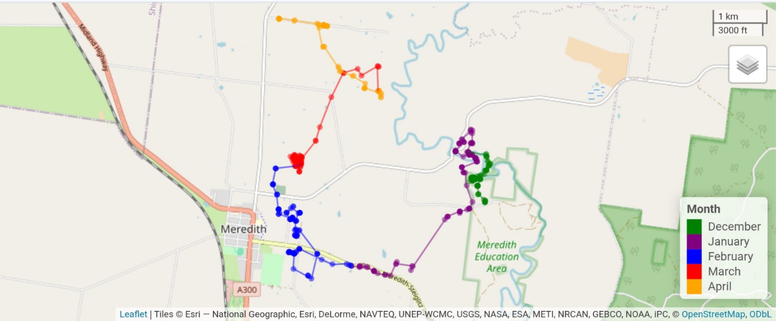

Figure 1. Mardi’s movement since release. Created by A. Lavinia (2026) using R Studio (Version 4.3.3) and OpenStreetMap data.
